**Project Design Phase-II**

**Data Flow Diagram & User Stories**

|  |  |
| --- | --- |
| Date | 13 November 2023 |
| Team ID | Team-592189 |
| Project Name | Lip Reading using Deep Learning |
| Maximum Marks | 4 Marks |

**Data Flow Diagrams:**

A Data Flow Diagram (DFD) is a traditional visual representation of the information flows within a system. A neat and clear DFD can depict the right amount of the system requirement graphically. It shows how data enters and leaves the system, what changes the information, and where data is stored.

Here is a more detailed description of each module:

* User Interface : This module is responsible for acquiring video input from the user as well as predicted output to the user.
* Pre-processing Module: This module is responsible for normalizing the video input and removing noise.
* Feature Extraction Module: This module is responsible for extracting features from the lip movements in the video input.
* Sequence Recognition Module: This module is responsible for recognizing words and phrases from the extracted features.
* Prediction Module: This module is responsible for generating the output of the lip reading system, which is a text representation of the recognized words and phrases to user interface module.

**Example:** [**(Simplified)**](https://developer.ibm.com/patterns/visualize-unstructured-text/)

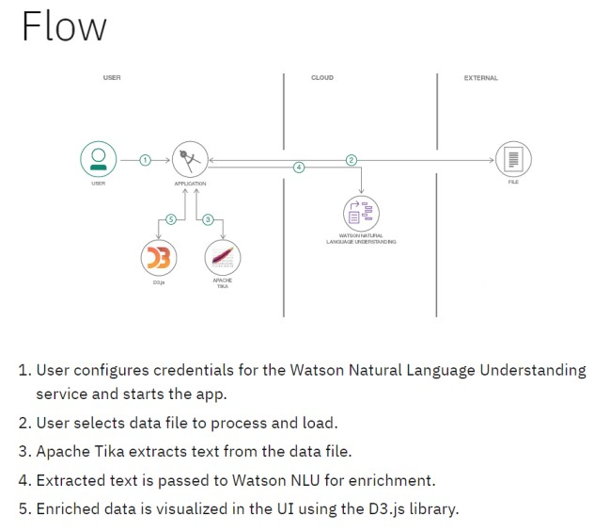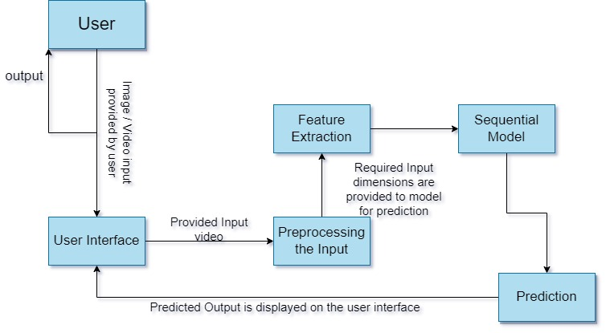

**User Stories**

The below template to show the list of all the user stories for the product.

|  |  |  |  |  |  |  |
| --- | --- | --- | --- | --- | --- | --- |
| **User Type** | **Functional**  **Requirement (Epic)** | **User Story**  **Number** | **User Story / Task** | **Acceptance criteria** | **Priority** | **Release** |
| Customer  (Mobile user) | Input format  Jpg, jpeg, png | USN-1 | As a user, I can provide input in jpg format for the application. | I can access my account/dashboard and my inputs. | High | Sprint-1 |
|  |  | USN-2 | As a user, I will receive a confirmation email once I have registered for the application | I can receive a confirmation email & click confirm | High | Sprint-1 |
|  |  | USN-3 | As a user, I can register for the application through Facebook | I can register & access the dashboard with Facebook Login | Low | Sprint-2 |
|  |  | USN-4 | As a user, I can register for the application through Gmail |  | Medium | Sprint-1 |
|  | Login | USN-5 | As a user, I can log into the application by entering my email & password |  | High | Sprint-1 |
|  | Dashboard |  |  |  |  |  |
| Customer (Web user) |  | USN - 1 | As a user It is simple from Web it is very flexible from the web. |  | High | Sprint-1 |
| Customer Care Executive |  |  |  |  |  |  |
| Administrator |  |  |  |  |  |  |
|  |  |  |  |  |  |  |
|  |  |  |  |  |  |  |
|  |  |  |  |  |  |  |